Truncated Pentagonal Pyramid

Definition
# Source: AI Source: Provided by: [Data Path: Persons Table -> ID Column: 1, Name_En Column: Motasem Essam] -> From: [ChatGPT] on [7/25/2026]
A Truncated Pentagonal Pyramid is a solid formed by cutting off the apex of a pentagonal pyramid with a plane parallel to its pentagonal base.
The resulting solid is called a Pentagonal Pyramid Frustum or Frustum of a Pentagonal Pyramid.
It has two parallel pentagonal bases of different sizes, connected by five trapezoidal lateral faces.
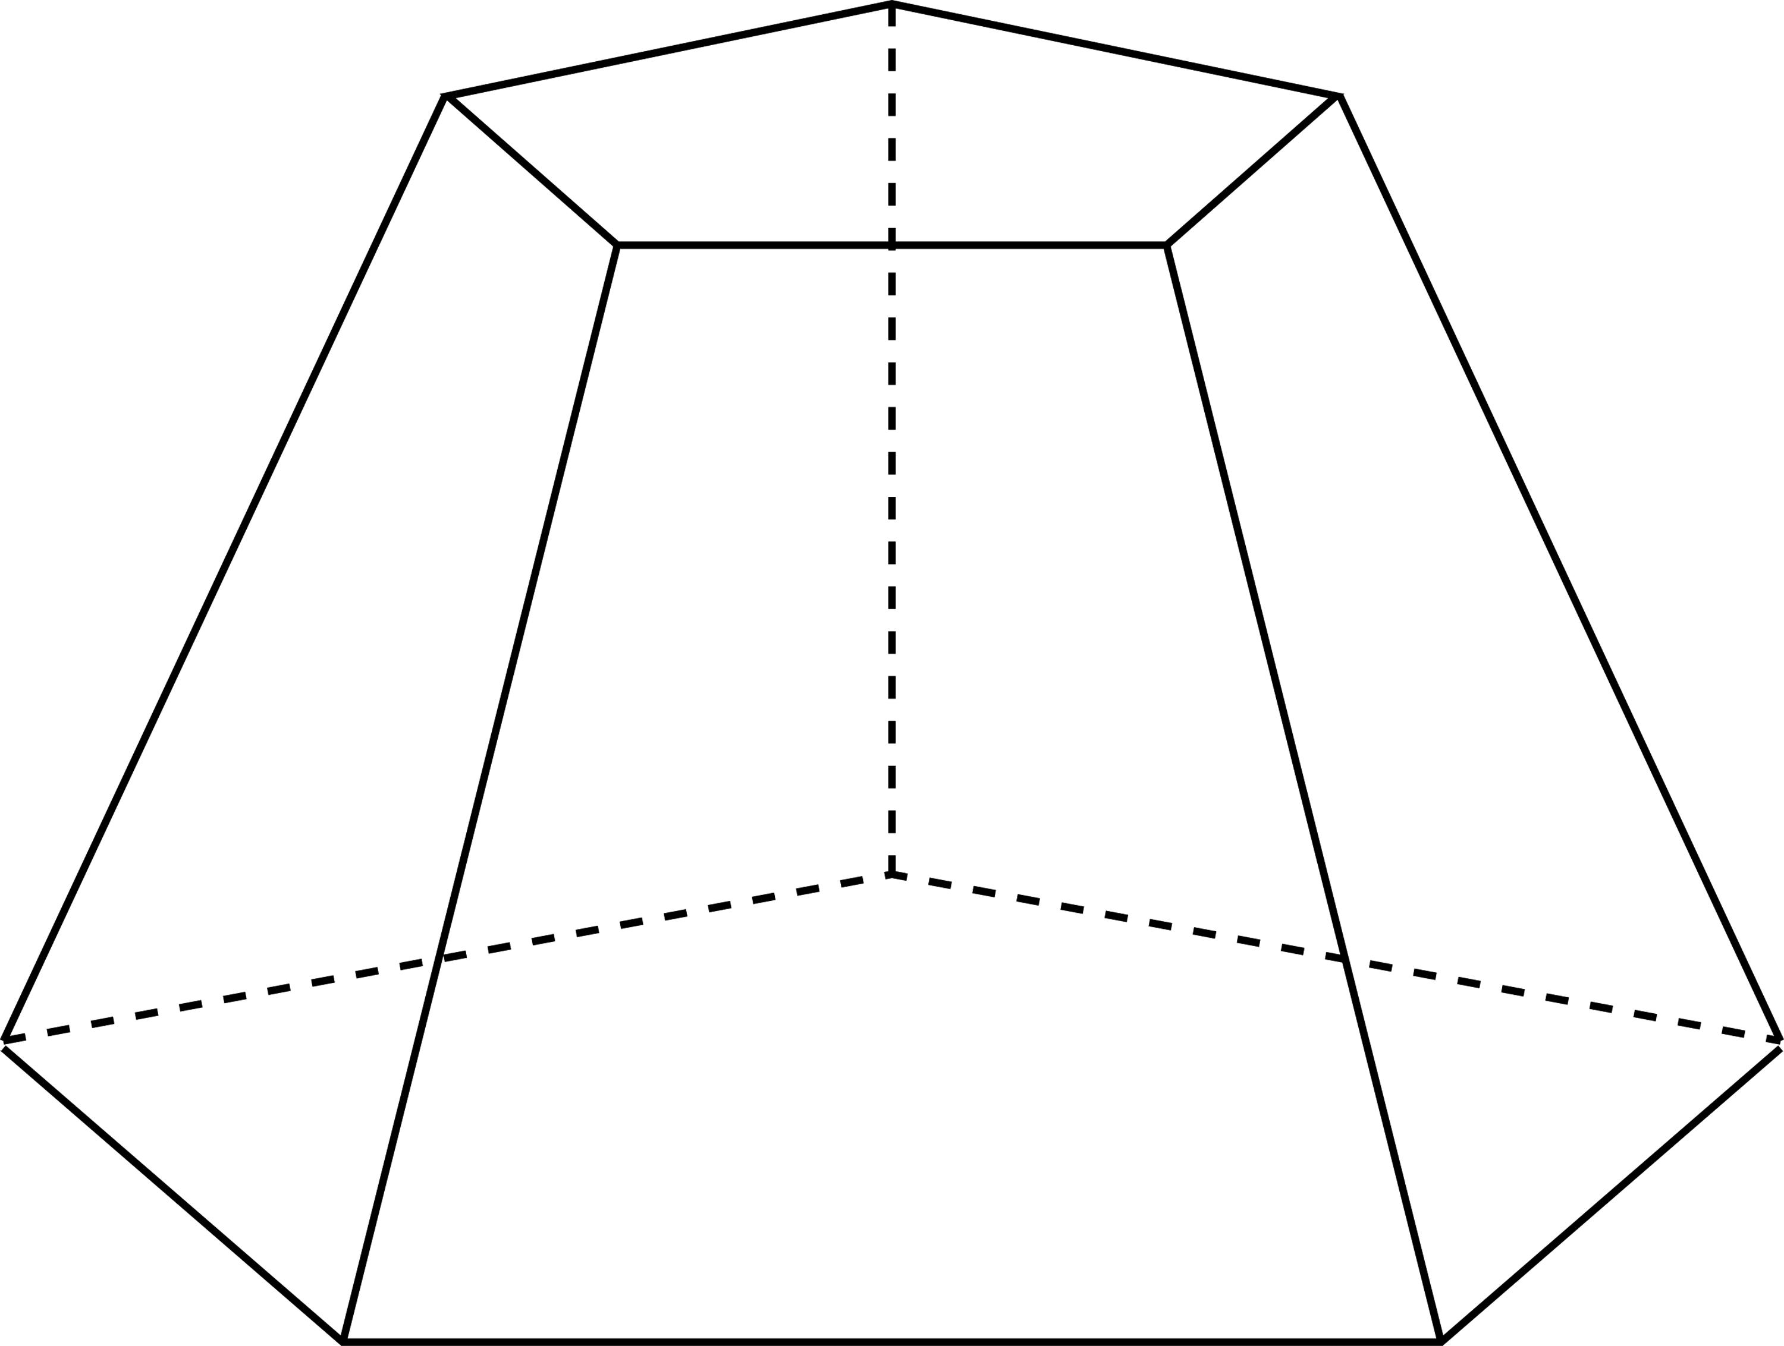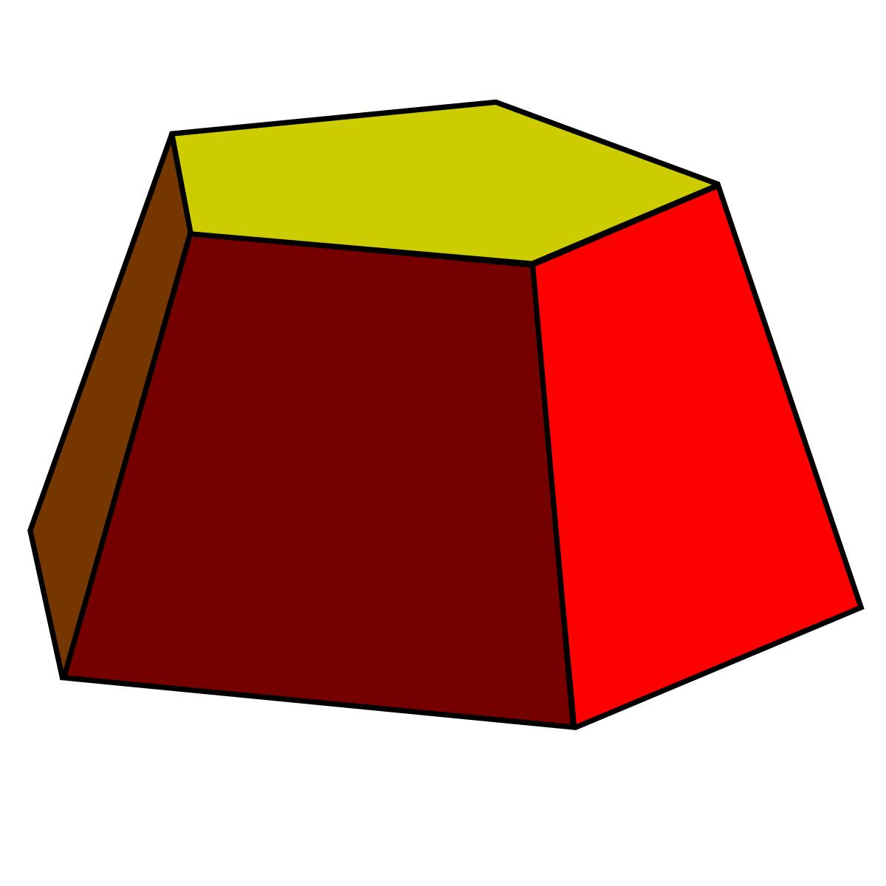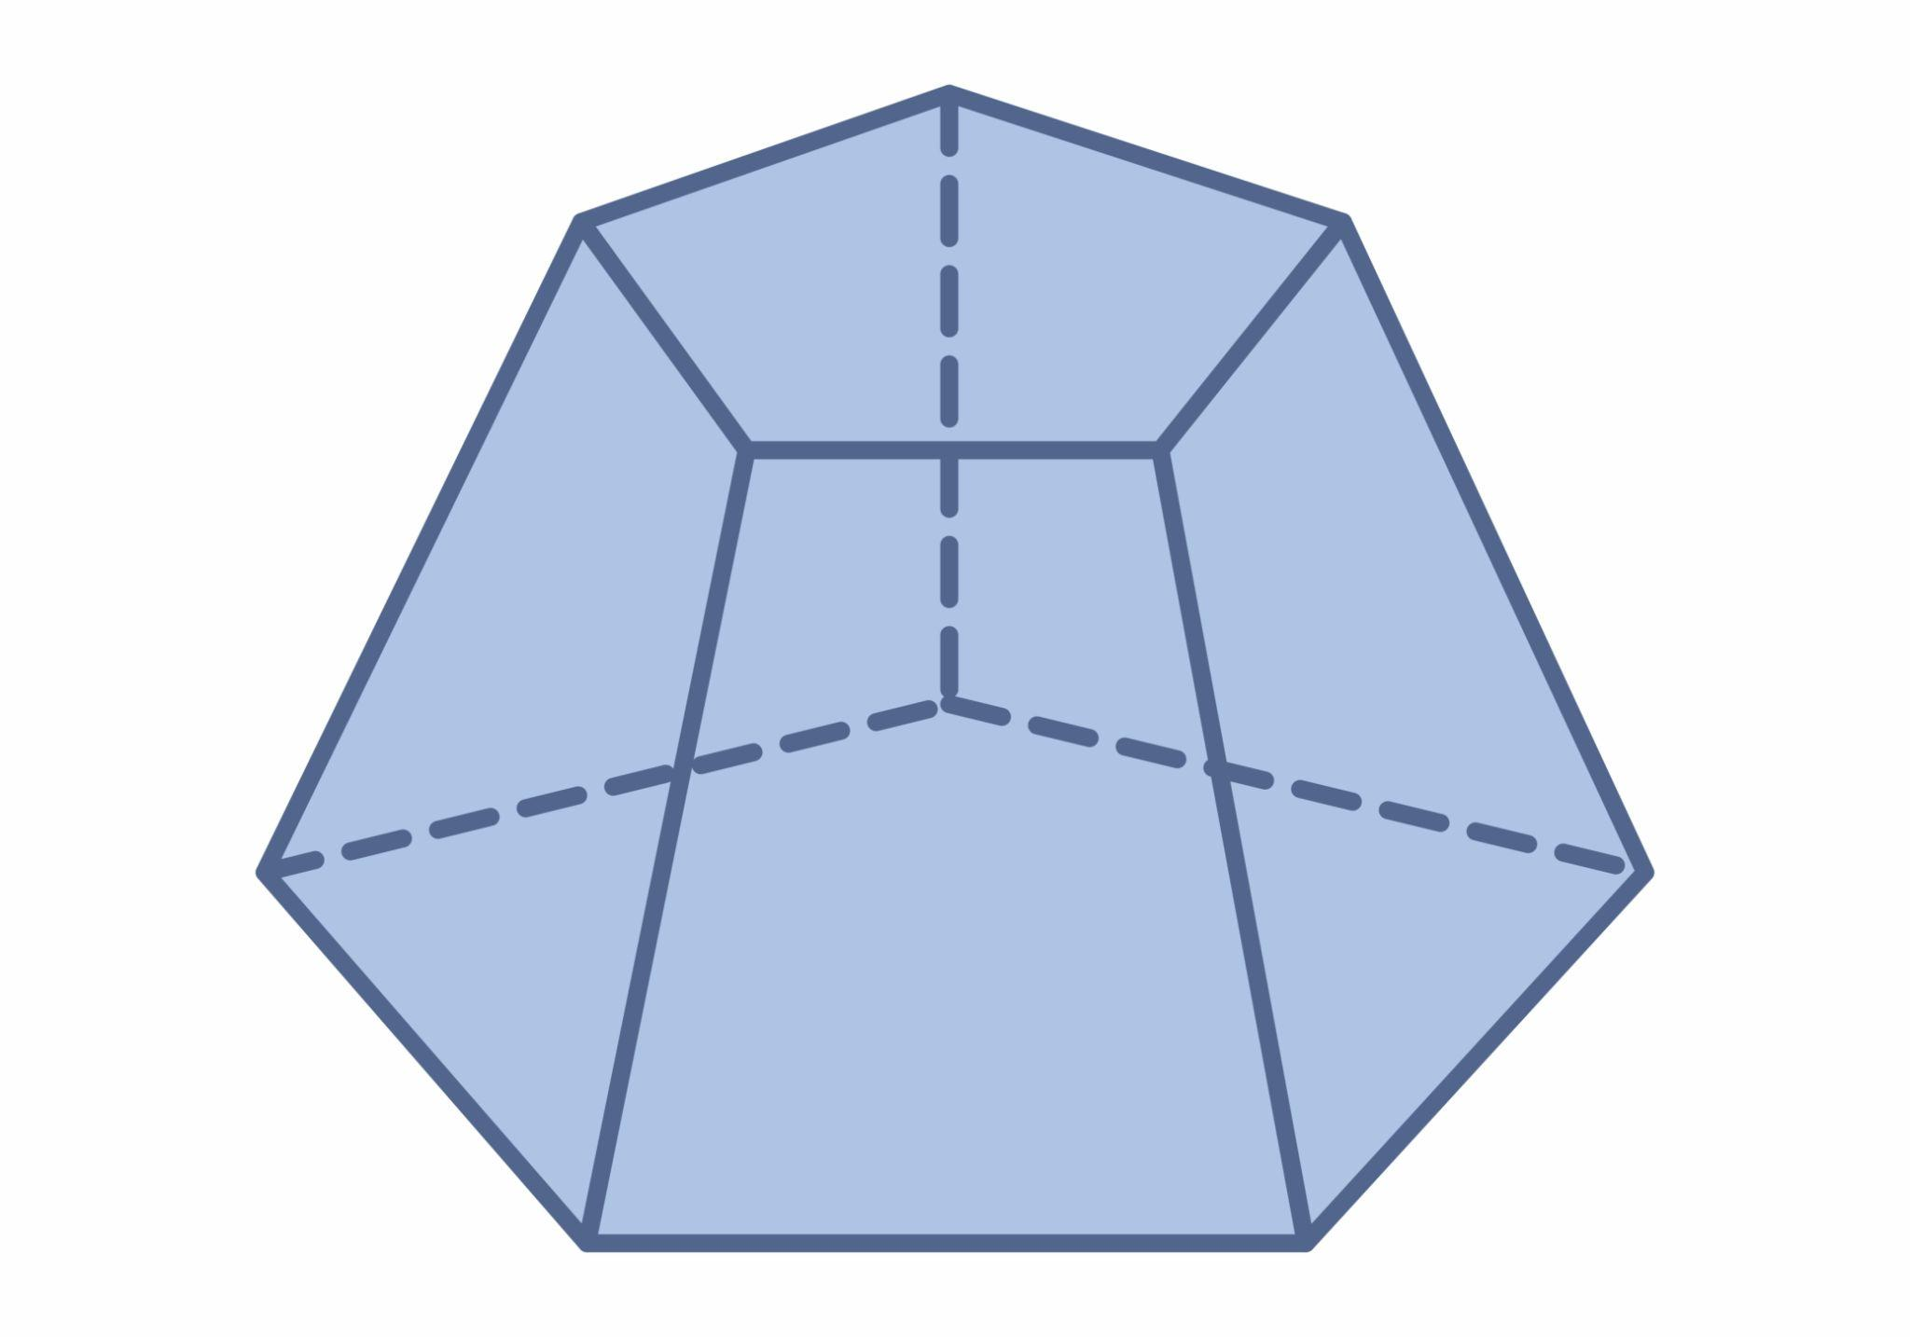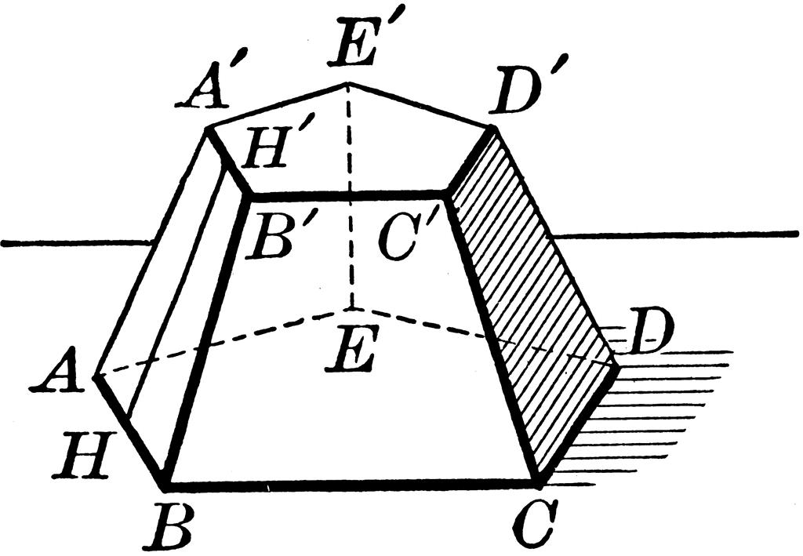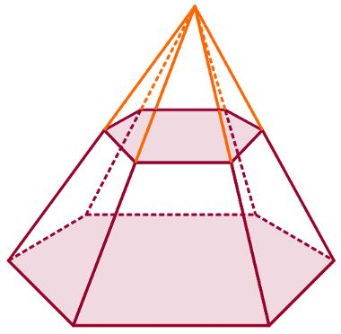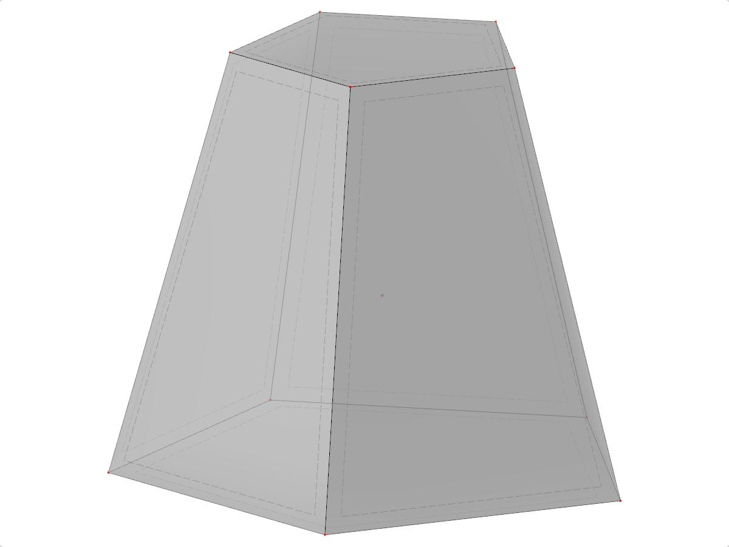

Geometric Structure
# Source: AI Source: Provided by: [Data Path: Persons Table -> ID Column: 1, Name_En Column: Motasem Essam] -> From: [ChatGPT] on [7/25/2026]
An original pentagonal pyramid consists of:
- 1 Pentagonal Base: The bottom face.
- 5 Triangular Lateral Faces: Meeting at the apex.
- 6 Vertices: Five base vertices and one apex.
- 10 Edges: Five base edges and five lateral edges.
After truncation:
- The original pentagonal base remains unchanged.
- A smaller pentagonal face is created by the cutting plane.
- The five original triangular lateral faces become trapezoidal faces.
- The original apex is removed.

Face Composition
# Source: AI Source: Provided by: [Data Path: Persons Table -> ID Column: 1, Name_En Column: Motasem Essam] -> From: [ChatGPT] on [7/25/2026]

Large Pentagonal Base
# Source: AI Source: Provided by: [Data Path: Persons Table -> ID Column: 1, Name_En Column: Motasem Essam] -> From: [ChatGPT] on [7/25/2026]
The original base of the pentagonal pyramid.

Small Pentagonal Base
# Source: AI Source: Provided by: [Data Path: Persons Table -> ID Column: 1, Name_En Column: Motasem Essam] -> From: [ChatGPT] on [7/25/2026]
The new face created by cutting off the apex with a plane parallel to the original base.

Trapezoidal Lateral Faces
# Source: AI Source: Provided by: [Data Path: Persons Table -> ID Column: 1, Name_En Column: Motasem Essam] -> From: [ChatGPT] on [7/25/2026]
The remaining portions of the original triangular lateral faces.
Total face composition:
- 2 Pentagonal Faces.
- 5 Trapezoidal Faces.
- 7 Faces in total.

Mathematical Properties
# Source: AI Source: Provided by: [Data Path: Persons Table -> ID Column: 1, Name_En Column: Motasem Essam] -> From: [ChatGPT] on [7/25/2026]
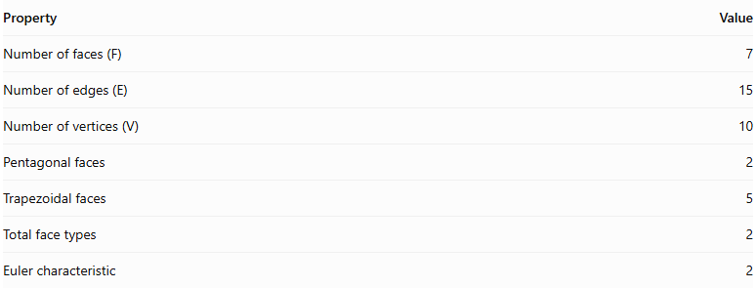
Property | Value
Number of faces (F) | 7
Number of edges (E) | 15
Number of vertices (V) | 10
Pentagonal faces | 2
Trapezoidal faces | 5
Total face types | 2
Euler characteristic | 2
Euler's Formula
$$V-E+F=2$$
$$10-15+7=2$$
Volume Formula
The volume of a pentagonal pyramid frustum is:
$$V=\frac{h}{3}(A_{1}+A_{2}+\sqrt{A_{1}A_{2}})$$
Where:
- $h$ = perpendicular distance between the two pentagonal bases.
- $A_{1}$ = area of the larger pentagonal base.
- $A_{2}$ = area of the smaller pentagonal base.
For regular pentagonal bases with side lengths $a$ and $b$:
$$A_{1}=\frac{a^{2}}{4}\sqrt{25+10\sqrt{5}}$$
$$A_{2}=\frac{b^{2}}{4}\sqrt{25+10\sqrt{5}}$$

Constructing Truncated Pentagonal Pyramid in Solid Geometry

Instruments Used
# Source: AI Source: Provided by: [Data Path: Persons Table -> ID Column: 1, Name_En Column: Motasem Essam] -> From: [ChatGPT] on [7/25/2026]
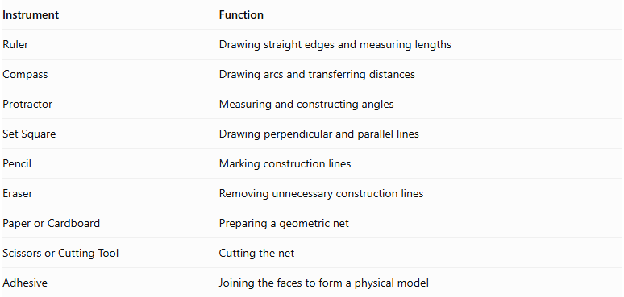
Instrument | Function
Ruler | Drawing straight edges and measuring lengths
Compass | Drawing arcs and transferring distances
Protractor | Measuring and constructing angles
Set Square | Drawing perpendicular and parallel lines
Pencil | Marking construction lines
Eraser | Removing unnecessary construction lines
Paper or Cardboard | Preparing a geometric net
Scissors or Cutting Tool | Cutting the net
Adhesive | Joining the faces to form a physical model

Construction Procedures

A. Original-Pyramid-Based Construction
# Source: AI Source: Provided by: [Data Path: Persons Table -> ID Column: 1, Name_En Column: Motasem Essam] -> From: [ChatGPT] on [7/25/2026]
- Draw a pentagonal base.
- Construct the original pentagonal pyramid by locating its apex.
- Draw a cutting plane parallel to the pentagonal base.
- Mark the intersections of the cutting plane with the five lateral edges.
- Remove the smaller upper portion conceptually or physically.
- Connect the intersection points to form the smaller pentagonal base.
- Darken the visible edges of the truncated solid.

B. Base-Based Construction
# Source: AI Source: Provided by: [Data Path: Persons Table -> ID Column: 1, Name_En Column: Motasem Essam] -> From: [ChatGPT] on [7/25/2026]
- Draw the larger pentagonal base.
- Draw a smaller similar pentagon above it.
- Ensure that the two bases are parallel.
- Match corresponding vertices.
- Connect the corresponding vertices using straight lines.
- Complete the five trapezoidal lateral faces.

C. Vertex-Connection Construction
# Source: AI Source: Provided by: [Data Path: Persons Table -> ID Column: 1, Name_En Column: Motasem Essam] -> From: [ChatGPT] on [7/25/2026]
- Identify the five vertices of the lower pentagon.
- Identify the five corresponding vertices of the upper pentagon.
- Connect each pair of corresponding vertices.
- Complete the lateral edges.
- Distinguish visible edges from hidden edges.

D. Edge-Based Construction
# Source: AI Source: Provided by: [Data Path: Persons Table -> ID Column: 1, Name_En Column: Motasem Essam] -> From: [ChatGPT] on [7/25/2026]
- Draw the five edges of the lower pentagonal base.
- Draw the five edges of the upper pentagonal base.
- Connect corresponding endpoints.
- Complete the fifteen edges of the solid.

E. Face-Based Construction
# Source: AI Source: Provided by: [Data Path: Persons Table -> ID Column: 1, Name_En Column: Motasem Essam] -> From: [ChatGPT] on [7/25/2026]
- Construct the lower pentagonal base.
- Construct the upper pentagonal base.
- Draw five trapezoidal lateral faces.
- Join the lateral faces to the two bases.

F. Net-Based Construction
# Source: AI Source: Provided by: [Data Path: Persons Table -> ID Column: 1, Name_En Column: Motasem Essam] -> From: [ChatGPT] on [7/25/2026]
- Draw one large pentagon.
- Draw one smaller similar pentagon.
- Construct five trapezoids around the larger pentagon.
- Add suitable joining tabs if preparing a physical model.
- Cut out the net.
- Fold the five trapezoids upward.
- Attach the smaller pentagon to the upper edges.
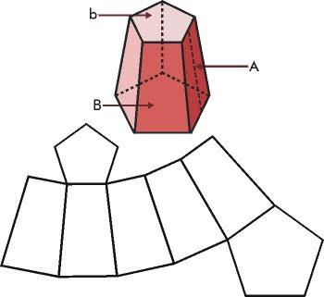

Key Points
# Source: AI Source: Provided by: [Data Path: Persons Table -> ID Column: 1, Name_En Column: Motasem Essam] -> From: [ChatGPT] on [7/25/2026]
- It originates from a pentagonal pyramid.
- It is formed by removing the apex using a plane parallel to the base.
- It has two parallel pentagonal bases of different sizes.
- It has five trapezoidal lateral faces.
- It contains 7 faces, 15 edges, and 10 vertices.
- It is classified as a pentagonal pyramid frustum.
- Its volume depends on the height and areas of its two bases.
Important terminology distinction:
A pentagonal pyramid frustum should not be confused with a vertex-truncated pentagonal pyramid, in which vertices are cut off individually without necessarily using a plane parallel to the original base.

Conclusion
# Source: AI Source: Provided by: [Data Path: Persons Table -> ID Column: 1, Name_En Column: Motasem Essam] -> From: [ChatGPT] on [7/25/2026]
The Truncated Pentagonal Pyramid is a pentagonal pyramid with its apex removed by a plane parallel to its base. It forms a pentagonal pyramid frustum consisting of two pentagonal bases and five trapezoidal lateral faces, with 7 faces, 15 edges, and 10 vertices.

